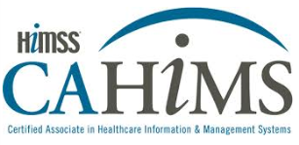
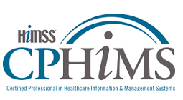

ARE YOU READY TO ADVANCE YOUR KNOWLEDGE AND TAKE YOUR CAREER TO THE NEXT LEVEL?

Wisconsin Dairyland HIMSS is proud to offer CAHIMS and CPHIMS Boot Camp review courses to help our members pursue their goals of becoming certified!

Boot Camps will begin at 7 a.m. with an optional networking hour (breakfast snacks and beverages will be available), and the course will begin at 8 a.m. sharp.

There will be breaks throughout the day, and lunch will be provided.

This one-day boot camp will help prepare you for your exam, and provide an opportunity to network with like-minded healthcare IT professionals!

Boot Camps will be offered on the following dates:

CAHIMS Bootcamp (Fond du Lac) - Saturday, October 14th
CPHIMS Bootcamp (Wausau) - Saturday, October 14th
CAHIMS Bootcamp (Wausau) - Saturday, November 4th
CPHIMS Bootcamp (Fond du Lac) - Saturday, November 4th

Visit the HIMSS Dairyland Chapter Website for full details or to register.

Don’t Wait - Register Today! There is a strict limit of 30 registrations per session!

