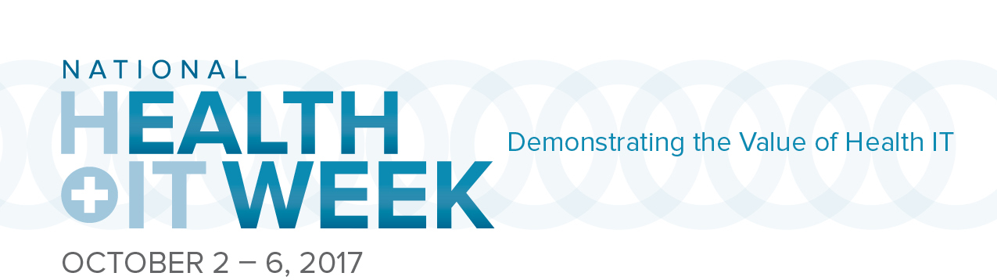

Fact Sheet
When: October 2-6th

What: National Health IT (NHIT) Week is a nationwide awareness week focused on the value of health IT. Each year, NHIT Week Partners educate industry and policy stakeholders on the value of health IT for the US healthcare system.

Who: National Health IT Week was founded by HIMSS and the Institute for e-Health Policy in 2006. The Administration, Congress, corporations, providers, and non-profit organizations around the country are all recognizing the value of shining the spotlight on health IT for one week every year. For a list of co-sponsors, click here.

Where: Nationwide. For a list of events, click here.

Why: It is an independent week made up of partner-driven events offering healthcare stakeholders an opportunity to unite under one banner, one message: the benefits health information technology can bring to U.S. healthcare.

Points of Engagement: National Health IT Week 2017 will demonstrate the value of health IT in:
- Supporting Healthcare Transformation
- Expanding Access to High Quality Care
- Increasing Economic Opportunity
- Making Communities Healthier

